Welcome to New Bethel Baptist Church
Sunday July 27, 2025

Welcome & Announcements Phil Morgan
Greeting of the Fellowship

Prelude Jaci Greig
*Gathering Hymn O for a Thousand Tongues to Sing #21
*Call to Worship Phil Morgan
Leader: All you looking for comfort,
People: Find here the arms of a loving God.
Leader: All you looking for direction,
People: Find here the hand of God to guide you.
Leader: All you hoping to end loneliness,
People: Find here the embrace of God and new friends.
Leader: All you searching for meaning,
People: Find here the Lord of Life and the Revealer of Truth.
Leader: All you seeking happiness,
People: Find here the deep joy of the risen Christ and the lasting peace of forgiveness
*Invocation and Lord’s Prayer (We use “sins”) Phil Morgan

Hymn In the Garden #635

Scripture Reading Psalm 138 Phil Morgan
One: Hear what God is saying to the people
Many: Thanks be to God!

Worship Prayer Pastor Dianna Cline
Prayer Song Cares Chorus
Prayer (During the prayer you will have the opportunity to call out concerns and praises)

*Hymn Sweet Hour of Prayer #640

Scripture Reflection Luke 11:1-13 Pastor Dianna Cline
“Connecting with God.”

*Hymn of Response Revive us Again #434
(This is a time to come forward to join the church, rededicate your life, or be baptized)

Invitation to Respond Phil Morgan
Offertory Jaci Greig
*Doxology
*Prayer Pastor Dianna Cline

If you are seeking bap'sm, to become a member at New Bethel, or would like someone to pray
with you, you are invited to come forward during this hymn.
If you are seeking bap'sm, to become a member at New Bethel, or would like someone to pray
with you, you are invited to come forward during this hymn.
Benediction Pastor Dianna Cline
Postlude Jaci Greig

Lay Leader: Phil Morgan
Pianist: Jaci Greig
Today’s Ushers: Liz Ballard & Greg West

Flowers arranged for July by Melody Lynch

CONTACT INFORMATION
New Bethel Baptist Church Website: www.newbethelbapt.org
8936 Southeastern Avenue E-mail: newbethelbapt@att.net
Indianapolis, IN 46239 Wi-fi password: NBBC8624381
317-862-4381

Worship Music Copyright and Live-Streaming Permissions
All selections ©1997 Word/Integrity Used by Permission.
CCLI License #1631733

Live-Streaming: CCS, WorshipCast, License #10868

The Lord’s Prayer

Our Father in heaven,
Hallowed be Your name.
Your kingdom come.
Your will be done
On earth as it is in heaven.
Give us this day our daily bread.
And forgive us our sins,
As we forgive our sinners.
And do not lead us into temptation,
But deliver us from the evil one.
For Yours is the kingdom and the power and the glory forever. Amen.

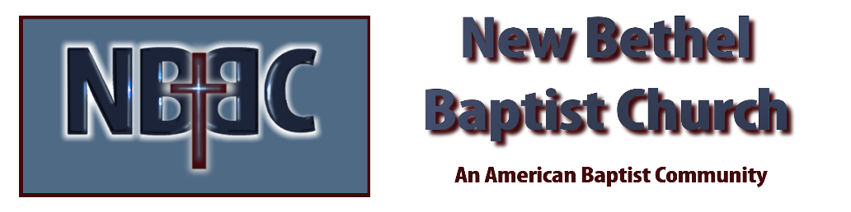

Sunday July 27, 2025



