Welcome to New Bethel Baptist Church
Sunday July 6, 2025

Welcome & Announcements Phil Morgan
Greeting of the Fellowship

Prelude God Bless the USA
*Gathering Hymn This is the Day #209

*Call to Worship Phil Morgan
Leader: Taste and see that the Lord is good.
People: Blessed is the one who takes refuge in God.
Leader: For in the shadow of the Almighty, we are clothed with compassion and love.
People: As the Lord showers mercy upon all who fear God, may we respond in a humble display of gentle care toward one another.

*Invocation and Lord’s Prayer

Hymn He Keeps Me Singing #746

Scripture Reading Psalm 66:1-9 Phil Morgan
One: Hear what God is saying to the people
Many: Thanks be to God!

Worship Prayer Pastor Dianna Cline
Prayer Song Cares Chorus
Prayer (During the prayer you will have the opportunity to call out concerns and praises)

*Hymn Peace Like a River #750

Scripture Reflection 2 Kings 5:1-14 Pastor Dianna Cline
What is the ‘Jordan River’ in our own lives?

*Hymn of Response Sunshine in My Soul #747
(This is a time to come forward to join the church, rededicate your life, or be baptized)

Invitation to Respond Phil Morgan
Offertory Jaci Greig
*Doxology
*Prayer Pastor Dianna Cline

Communion Hymn In Remembrance #461
Communion
If you are seeking bap'sm, to become a member at New Bethel, or would like someone to pray
with you, you are invited to come forward during this hymn.
If you are seeking bap'sm, to become a member at New Bethel, or would like someone to pray
with you, you are invited to come forward during this hymn.
Benediction Pastor Dianna Cline
Postlude Jaci Greig

Lay Leader: Phil Morgan
Pianist: Jaci Greig
Today’s Ushers: Donna Carnes and Patrick Lynch
Deacons: Ruth Ann and Sherry

Flowers arranged for July by Melody Lynch

CONTACT INFORMATION
New Bethel Baptist Church Website: www.newbethelbapt.org
8936 Southeastern Avenue E-mail: newbethelbapt@att.net
Indianapolis, IN 46239 Wi-fi password: NBBC8624381
317-862-4381

Worship Music Copyright and Live-Streaming Permissions
All selections ©1997 Word/Integrity Used by Permission.
CCLI License #1631733

Live-Streaming: CCS, WorshipCast, License #10868

Purpose Statement

New Bethel Baptist Church exists for the purpose of serving God in the following ways:
- Worshipping as a community of faith in Jesus Christ.
- Instruction in developing a closer relationship with God.
- Fellowship with other believers.
- Evangelism as sharing the good news with our neighbors near and far.
- Service in our church community to honor God.

Vision Statement

The vision of New Bethel Baptist Church is to be a fellowship where everyone can worship, learn, and serve in an accepting community of believers.

Our vision will be lived out through our core values

1. Acceptance
Accepting all God’s children

2. Family
Ministering through Christian Education for all ages
Spiritual gifts and Christian Love
Growing as a family

3. Compassion
Providing care and support
Sharing the Good News locally and globally

4. Spiritual Growth
Discovery of spiritual gifts
Understanding God’s purpose

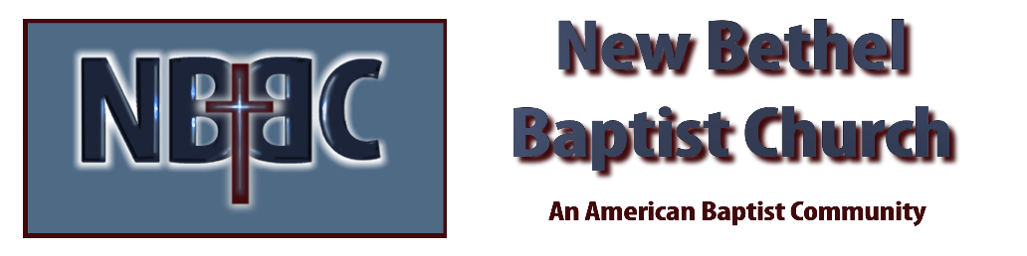

Sunday July 6, 2025



