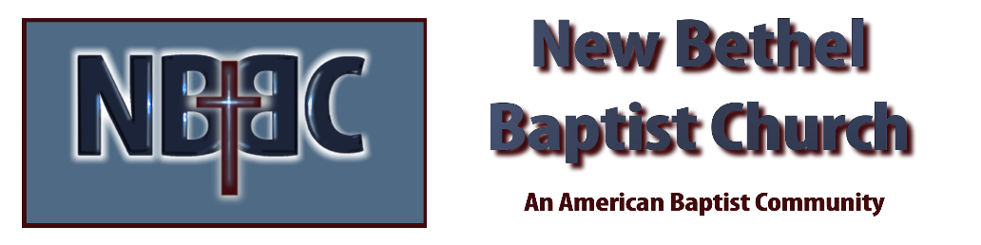

Sunday, August 31, 2025

Welcome & Announcements Phil Morgan
Greeting of the Fellowship
*Gathering Hymn We have come into His house #224
*Call to Worship Phil Morgan
Leader: Lord God, servanthood is not easy for us. We are attracted to the illusions of power and rank. We are seduced by wealth and privilege. We are accustomed to success and surrounded by our accomplishments. The towel and the basin of servanthood, the stooping of ministry, the listening, gentleness and openness of the serving spirit are so alien to much of our society and to us.
People: Teach us to love, teach us to serve, teach us gentle strength and warm authority. Teach us how to bind up the brokenness. Teach us to be stewards of our powers, custodians of our communities. Teach us the sheer exploding joy of service.

*Invocation and Lord’s Prayer (We use “sins”) Phil Morgan

Scripture Reading Psalm 112 Phil Morgan
One: Hear what God is saying to the people
Many: Thanks be to God!

Worship Prayer Pastor Dianna Cline
Prayer Song Cares Chorus
Prayer (During the prayer you will have the opportunity to call out concerns and praises)

*Hymn Love Lifted Me #508
Scripture Reflection Luke 14:1,7-14 Pastor Dianna Cline
“Meal Time”

*Hymn of Response Come to the Table #464
(This is a time to come forward to join the church, rededicate your life, or be baptized)

Invitation to Respond Phil Morgan

Offertory
*Doxology
*Prayer Pastor Dianna Cline
If you are seeking bap'sm, to become a member at New Bethel, or would like someone to pray
with you, you are invited to come forward during this hymn.
If you are seeking bap'sm, to become a member at New Bethel, or would like someone to pray
with you, you are invited to come forward during this hymn.

Benediction

Lay Leader: Phil Morgan
Today’s Ushers: Sue and Jim

Flowers for August were arranged by Ruth Ann Mills

CONTACT INFORMATION
New Bethel Baptist Church Website: www.newbethelbapt.org
8936 Southeastern Avenue E-mail: newbethelbapt@att.net Indianapolis, IN 46239 Wi-fi password: NBBC8624381
317-862-4381
Worship Music Copyright and Live-Streaming Permissions
All selections ©1997 Word/Integrity Used by Permission.
CCLI License #1631733

Live-Streaming: CCS, WorshipCast, License #10868

