Welcome to New Bethel Baptist Church
Sunday August 3, 2025

Welcome & Announcements Phil Morgan
Greeting of the Fellowship

Prelude Jaci Greig
*Gathering Hymn We have come into His House #224
*Call to Worship Phil Morgan
One: Come, join and sing! Our God is ruler of all creation.
All: Come, stand and praise! Our God is sovereign over all the earth.
One: Come, lift your hearts! Jesus, our Savior, has risen from the dead.
All: Come, rest your souls! Jesus, our Savior, has defeated sin and death.
One: Come, watch and pray! The Holy Spirit is in this place.
All: Come, be still and listen! The Holy Spirit will guide us all into worship.
One: Come now and worship! Give praise to God, the Father; Jesus Christ, his Son; and the sacred Holy Ghost. All: Amen.

*Invocation and Lord’s Prayer (We use “sins”) Phil Morgan

Hymn Come, Christians Join to Sing #225

Scripture Reading Psalm 49:1-12 Phil Morgan
One: Hear what God is saying to the people
Many: Thanks be to God!

Worship Prayer Pastor Dianna Cline
Prayer Song Cares Chorus
Prayer (During the prayer you will have the opportunity to call out concerns and praises)

*Hymn Rejoice, The Lord is King #370

Scripture Reflection Colossians 3:1-11 Pastor Dianna Cline
“Knowing Thyself”

*Hymn of Response Take my Life and let it be Consecrated #597 (vs. 1,5 & 6)
(This is a time to come forward to join the church, rededicate your life, or be baptized)

Invitation to Respond Phil Morgan
Offertory Jaci Greig
*Doxology
*Prayer Pastor Dianna Cline

If you are seeking bap'sm, to become a member at New Bethel, or would like someone to pray
with you, you are invited to come forward during this hymn.
If you are seeking bap'sm, to become a member at New Bethel, or would like someone to pray
with you, you are invited to come forward during this hymn.
Communion Hymn In Remembrance #461
Communion
Benediction Blest Be the Tie Pastor Dianna Cline
Postlude Jaci Greig

Lay Leader: Phil Morgan
Pianist: Jaci Greig
Today’s Ushers: Donna Carnes & Patrick Lynch
Deacons: Sherry & Sue

Flowers for August were designed by Ruth Ann Mills

CONTACT INFORMATION
New Bethel Baptist Church Website: www.newbethelbapt.org
8936 Southeastern Avenue E-mail: newbethelbapt@att.net
Indianapolis, IN 46239 Wi-fi password: NBBC8624381
317-862-4381

Worship Music Copyright and Live-Streaming Permissions
All selections ©1997 Word/Integrity Used by Permission.
CCLI License #1631733

Live-Streaming: CCS, WorshipCast, License #10868

The Lord’s Prayer

Our Father in heaven,
Hallowed be Your name.
Your kingdom come.
Your will be done
On earth as it is in heaven.
Give us this day our daily bread.
And forgive us our sins,
As we forgive our sinners.
And do not lead us into temptation,
But deliver us from the evil one.
For Yours is the kingdom and the power and the glory forever. Amen.

,

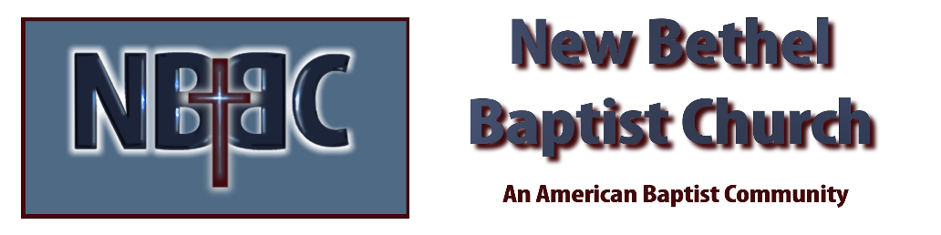

Sunday August 3, 2025



