Welcome to New Bethel Baptist Church
Sunday August 10, 2025

Welcome & Announcements Phil Morgan
Greeting of the Fellowship

Prelude Jaci Greig

*Gathering Hymn We have come into His House #224
*Call to Worship Phil Morgan
We’re here because we believe in the unseen presence of God. We believe that although we can’t see him physically with our eyes, the Lord of the universe is in this place this morning. And our souls will be nourished as we once again experience the perspective that comes from his presence. Join with us to worship our Creator and Sustainer, the Ancient of Days.

*Invocation and Lord’s Prayer (We use “sins”) Phil Morgan

Hymn All Praise to our Redeeming Lord #221

Scripture Reading Psalm 33:12-22 Phil Morgan
One: Hear what God is saying to the people
Many: Thanks be to God!

Worship Prayer Pastor Dianna Cline
Prayer Song Cares Chorus
Prayer (During the prayer you will have the opportunity to call out concerns and praises)

*Hymn I give all to You #595

Scripture Reflection Isaiah 1:1, 10-20 Pastor Dianna Cline
“What does God want, anyway?”

*Hymn of Response Grace Greater than Our Sin #344
(This is a time to come forward to join the church, rededicate your life, or be baptized)

Invitation to Respond Phil Morgan
Offertory Jaci Greig
*Doxology
*Prayer Pastor Dianna Cline

If you are seeking bap'sm, to become a member at New Bethel, or would like someone to pray
with you, you are invited to come forward during this hymn.
If you are seeking bap'sm, to become a member at New Bethel, or would like someone to pray
with you, you are invited to come forward during this hymn.
Benediction Pastor Dianna Cline
Postlude Jaci Greig

Lay Leader: Phil Morgan
Pianist: Jaci Greig
Today’s Ushers: Jeannine Toon & Sherry Shoemaker

Flowers for August were arranged by Ruth Ann Mills

CONTACT INFORMATION
New Bethel Baptist Church Website: www.newbethelbapt.org
8936 Southeastern Avenue E-mail: newbethelbapt@att.net
Indianapolis, IN 46239 Wi-fi password: NBBC8624381
317-862-4381

Worship Music Copyright and Live-Streaming Permissions
All selections ©1997 Word/Integrity Used by Permission.
CCLI License #1631733

Live-Streaming: CCS, WorshipCast, License #10868

The Lord’s Prayer

Our Father in heaven,
Hallowed be Your name.
Your kingdom come.
Your will be done
On earth as it is in heaven.
Give us this day our daily bread.
And forgive us our sins,
As we forgive our sinners.
And do not lead us into temptation,
But deliver us from the evil one.
For Yours is the kingdom and the power and the glory forever. Amen.

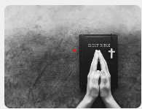
,

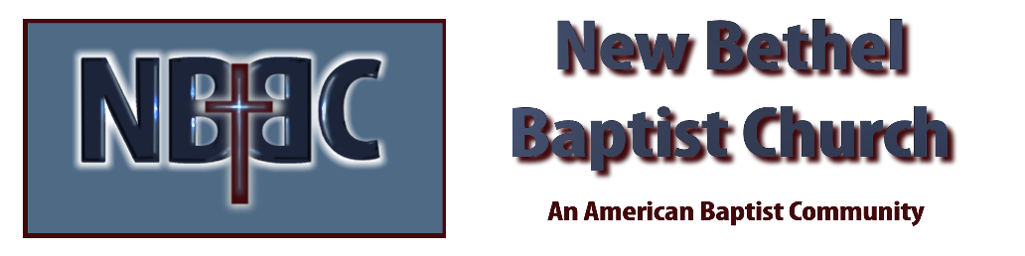

Sunday August 10, 2025



