Welcome to New Bethel Baptist Church
Sunday August 17, 2025

Welcome & Announcements Phil Morgan
Greeting of the Fellowship

Prelude Jaci Greig

*Gathering Hymn Praise Him! Praise Him! #12
*Call to Worship Phil Morgan
One: Let justice flow like a mighty stream.
All: Let truth stand tall like the majestic oak.
One: Let hope be as broad as the distant horizon.
All: Let kindness rain like a summer shower.
One: Let love blossom in every heart.
All: Let music soar and stir our feet to action and our spirits to praise.

*Invocation and Lord’s Prayer (We use “sins”) Phil Morgan

Hymn All Hail the Power of Jesus’ Name #43

Scripture Reading Psalm 82 Phil Morgan
One: Hear what God is saying to the people
Many: Thanks be to God!

Worship Prayer Pastor Dianna Cline
Prayer Song Cares Chorus
Prayer (During the prayer you will have the opportunity to call out concerns and praises)

*Hymn Stand up, Stand up for Jesus #730

Scripture Reflection Isaiah 5:1-7 Pastor Dianna Cline
“God’s Development Project”

*Hymn of Response Onward, Christian Soldiers #731
(This is a time to come forward to join the church, rededicate your life, or be baptized)

Invitation to Respond Phil Morgan
Offertory Jaci Greig
*Doxology
*Prayer Pastor Dianna Cline

If you are seeking bap'sm, to become a member at New Bethel, or would like someone to pray
with you, you are invited to come forward during this hymn.
If you are seeking bap'sm, to become a member at New Bethel, or would like someone to pray
with you, you are invited to come forward during this hymn.
Benediction Pastor Dianna Cline
Postlude Jaci Greig

Lay Leader: Phil Morgan
Pianist: Jaci Greig
Today’s Ushers: Patty Dammann & Pat Morgan

Flowers for August were arranged by Ruth Ann Mills

CONTACT INFORMATION
New Bethel Baptist Church Website: www.newbethelbapt.org
8936 Southeastern Avenue E-mail: newbethelbapt@att.net
Indianapolis, IN 46239 Wi-fi password: NBBC8624381
317-862-4381

Worship Music Copyright and Live-Streaming Permissions
All selections ©1997 Word/Integrity Used by Permission.
CCLI License #1631733

Live-Streaming: CCS, WorshipCast, License #10868

The Lord’s Prayer

Our Father in heaven,
Hallowed be Your name.
Your kingdom come.
Your will be done
On earth as it is in heaven.
Give us this day our daily bread.
And forgive us our sins,
As we forgive our sinners.
And do not lead us into temptation,
But deliver us from the evil one.
For Yours is the kingdom and the power and the glory forever. Amen.


,

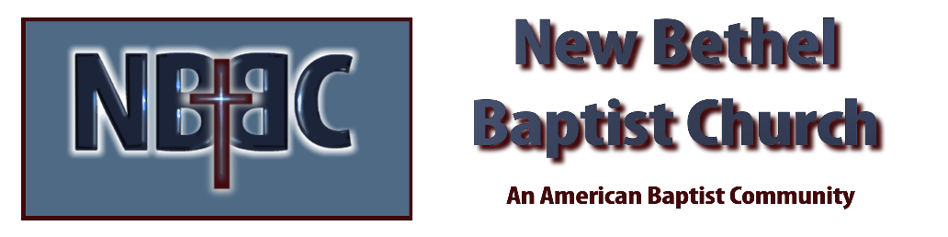

Sunday August 17, 2025



