Welcome to New Bethel Baptist Church
Sunday August 24, 2025

Welcome & Announcements Phil Morgan
Greeting of the Fellowship

*Gathering Hymn Amazing Grace #343
*Call to Worship Phil Morgan
One: Come, Lord Jesus, here where we have gathered in your name.
All: We need to hear your voice and learn of you.
One: Speak to us of gentleness and strength.
All: In your compassion, draw us into your merciful embrace.
One: Hush the distracting thoughts clamoring for attention in our minds.
All: Center our spirits in your peace.
One: Open our hearts to your wise teaching, that we may grow wise and strong in the ways of your kingdom.

*Invocation and Lord’s Prayer (We use “sins”) Phil Morgan

Scripture Reading Psalm 103:1-8 Phil Morgan
One: Hear what God is saying to the people
Many: Thanks be to God!

Worship Prayer Pastor Dianna Cline
Prayer Song Cares Chorus
Prayer (During the prayer you will have the opportunity to call out concerns and praises)

*Hymn Love Lifted Me #508

Scripture Reflection Jeremiah 1:4-10 Pastor Dianna Cline
“Holy Collisions”

*Hymn of Response It is well with my soul #705
(This is a time to come forward to join the church, rededicate your life, or be baptized)

Invitation to Respond Phil Morgan
Offertory
*Doxology
*Prayer Pastor Dianna Cline

If you are seeking bap'sm, to become a member at New Bethel, or would like someone to pray
with you, you are invited to come forward during this hymn.
If you are seeking bap'sm, to become a member at New Bethel, or would like someone to pray
with you, you are invited to come forward during this hymn.
Benediction Pastor Dianna Cline

Lay Leader: Phil Morgan
Today’s Ushers: Liz Ballard & Greg West

Flowers for August were arranged by Ruth Ann Mills

CONTACT INFORMATION
New Bethel Baptist Church Website: www.newbethelbapt.org
8936 Southeastern Avenue E-mail: newbethelbapt@att.net
Indianapolis, IN 46239 Wi-fi password: NBBC8624381
317-862-4381

Worship Music Copyright and Live-Streaming Permissions
All selections ©1997 Word/Integrity Used by Permission.
CCLI License #1631733

Live-Streaming: CCS, WorshipCast, License #10868

The Lord’s Prayer

Our Father in heaven,
Hallowed be Your name.
Your kingdom come.
Your will be done
On earth as it is in heaven.
Give us this day our daily bread.
And forgive us our sins,
As we forgive our sinners.
And do not lead us into temptation,
But deliver us from the evil one.
For Yours is the kingdom and the power and the glory forever. Amen.

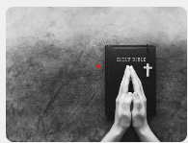
,

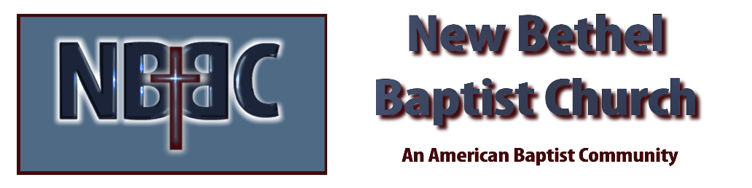

Sunday August 24, 2025

