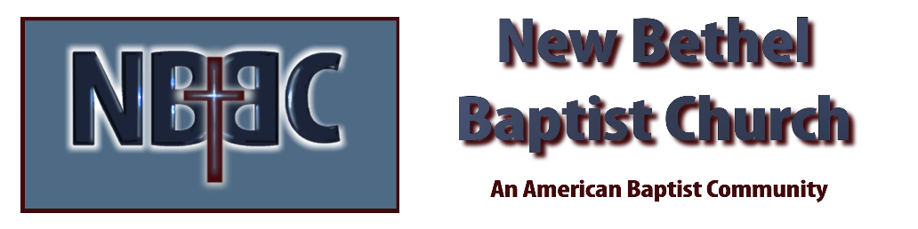
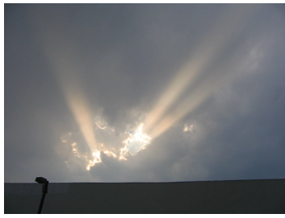
Sunday, September 7, 2025

Welcome & Announcements Phil Morgan
Greeting of the Fellowship
*Gathering Hymn Come Let Us Worship & Bow Down #227
*Call to Worship Phil Morgan
Leader: We seek a big enough God who has overcome all things.
People: Jesus said, “If you would be my disciple, you must deny yourself and take up the cross.”
All: We take heart knowing that “Nothing can separate us from God’s love, which enables us to do all things.” This we do by the promise of faith guaranteed by God’s abounding grace. Amen.

*Invocation and Lord’s Prayer (We use “sins”) Phil Morgan
Hymn His Name is Wonderful #118
Scripture Reading Psalm 1 Phil Morgan
One: Hear what God is saying to the people
Many: Thanks be to God!

Worship Prayer Pastor Dianna Cline
Prayer Song Cares Chorus
Prayer (During the prayer you will have the opportunity to call out concerns and praises)

*Hymn He Leadeth Me #690
Scripture Reflection Luke 14:25-33 Pastor Dianna Cline
“Let Them!”

*Hymn of Response To God Be the Glory #56
(This is a time to come forward to join the church, rededicate your life, or be baptized)

Invitation to Respond Phil Morgan

Offertory
*Doxology
*Prayer Pastor Dianna Cline
Communion Hymn Come to the Table #464
Communion
If you are seeking bap'sm, to become a member at New Bethel, or would like someone to pray
with you, you are invited to come forward during this hymn.
If you are seeking bap'sm, to become a member at New Bethel, or would like someone to pray
with you, you are invited to come forward during this hymn.

Benediction

Lay Leader: Phil Morgan
Today’s Ushers: Donna Carnes and Patrick Lynch
Deacons: Sue and Phil

CONTACT INFORMATION
New Bethel Baptist Church Website: www.newbethelbapt.org
8936 Southeastern Avenue E-mail: newbethelbapt@att.net Indianapolis, IN 46239 Wi-fi password: NBBC8624381
317-862-4381
Worship Music Copyright and Live-Streaming Permissions
All selections ©1997 Word/Integrity Used by Permission.
CCLI License #1631733

Live-Streaming: CCS, WorshipCast, License #10868

