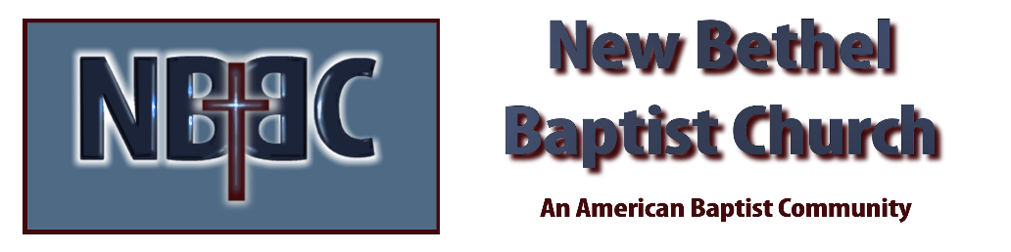

Sunday, September 21, 2025
Welcome & Announcements Phil Morgan
Greeting of the Fellowship
Prelude Jaci Greig
*Gathering Hymn We Bring the Sacrifice of Praise #213 (sing twice)
*Call to Worship Phil Morgan
Leader: Lord God, servanthood is not easy for us. We are attracted to the illusions of power and rank. We are seduced by wealth and privilege. We are accustomed to success and surrounded by our accomplishments. The towel and the basin of servanthood, the stooping of ministry, the listening, gentleness and openness of the serving spirit are so alien to much of our society and to us.
People: Teach us to love, teach us to serve, teach us gentle strength and warm authority. Teach us how to bind up the brokenness. Teach us to be stewards of our powers, custodians of our communities. Teach us the sheer exploding joy of service.

*Invocation and Lord’s Prayer (We use “sins”) Phil Morgan
Scripture Reading Psalm 113 Phil Morgan
One: Hear what God is saying to the people
Many: Thanks be to God!

Worship Prayer Pastor Dianna Cline
Prayer Song Cares Chorus
Prayer (During the prayer you will have the opportunity to call out concerns and praises)

*Hymn Little is Much when God is in it #661
Scripture Reflection Luke 16:1-13 Pastor Dianna Cline
“Being Faithful with what you have”

*Hymn of Response Take My Life and Let it be Consecrated #597 (vs.1,5 &6)
(This is a time to come forward to join the church, rededicate your life, or be baptized)

Invitation to Respond Phil Morgan

Offertory Special Music by Kevin Stone and Phil Morgan
*Doxology
*Prayer Pastor Dianna Cline
Benediction
Postlude Jaci Greig

Lay Leader: Phil Morgan
Pianist: Jaci Greig
Today’s Ushers: Patty Dammann and Pat Morgan

Sanctuary Decorations by Liz Ballard

CONTACT INFORMATION
New Bethel Baptist Church Website: www.newbethelbapt.org
8936 Southeastern Avenue E-mail: newbethelbapt@att.net Indianapolis, IN 46239 Wi-fi password: NBBC8624381
317-862-4381
Worship Music Copyright and Live-Streaming Permissions
All selections ©1997 Word/Integrity Used by Permission.
CCLI License #1631733

Live-Streaming: CCS, WorshipCast, License #10868

