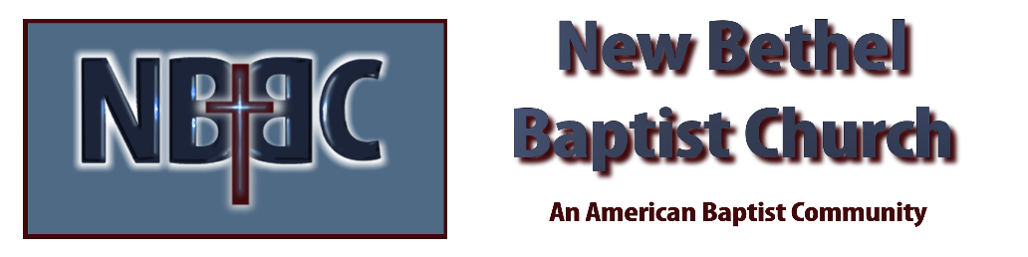

Sunday, September 28, 2025
Welcome & Announcements Phil Morgan
Greeting of the Fellowship
Prelude Jaci Greig
*Gathering Hymn O for a thousand tongues to sing #21 (vs 1,2,3 & 5)
*Call to Worship Phil Morgan
# 51 out of the hymnal

*Invocation and Lord’s Prayer (We use “sins”) Phil Morgan
Scripture Reading Psalm 146 Phil Morgan
One: Hear what God is saying to the people
Many: Thanks be to God!

Worship Prayer Pastor Dianna Cline
Prayer Song Cares Chorus
Prayer (During the prayer you will have the opportunity to call out concerns and praises)

*Hymn Make Me a Blessing #670

Scripture Reflection Jeremiah 32:1-3, 8-15 Pastor Dianna Cline
“Investments”

*Hymn of Response We are an offering #678
(This is a time to come forward to join the church, rededicate your life, or be baptized)

Invitation to Respond Phil Morgan

Offertory
*Doxology
*Prayer Pastor Dianna Cline
Benediction
Postlude Jaci Greig

Lay Leader: Phil Morgan
Pianist: Jaci Greig
Today’s Ushers: Liz Ballard and Greg West

Sanctuary Decorations by Liz Ballard

CONTACT INFORMATION
New Bethel Baptist Church Website: www.newbethelbapt.org
8936 Southeastern Avenue E-mail: newbethelbapt@att.net Indianapolis, IN 46239 Wi-fi password: NBBC8624381
317-862-4381
Worship Music Copyright and Live-Streaming Permissions
All selections ©1997 Word/Integrity Used by Permission.
CCLI License #1631733

Live-Streaming: CCS, WorshipCast, License #10868

