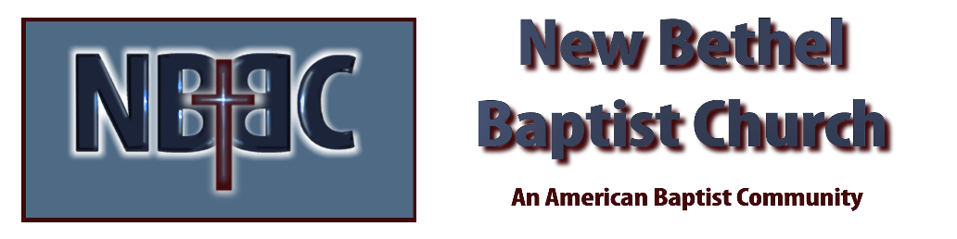

Sunday, October 12, 2025
Prelude Jaci Greig
Welcome & Announcements Phil Morgan
*Gathering Hymn This is the Day #209 (2x’s)
*Call to Worship Phil Morgan
Leader: Let us hear the Word of the Lord. Let us be warmed by its fire
burning in our hearts.
People: God’s Word is a lamp to our feet, a light along the pathway.
Leader: In the presence of the Word, revealed in Jesus Christ, written in Scripture, praised in hymns, proclaimed in preaching, expressed in prayer.
People: Now here in this time together, let us praise God as we join in prayer.

*Invocation and Lord’s Prayer (We use “sins”) Phil Morgan
Hymn Majesty #10

Scripture Reading Psalm 111 Phil Morgan
One: Hear what God is saying to the people
Many: Thanks be to God!

Worship Prayer Pastor Dianna Cline
Prayer Song Cares Chorus
Prayer (During the prayer you will have the opportunity to call out concerns and praises)

Scripture Reflection 2 Timothy 2:8-15 Pastor Dianna Cline
“Living Differently”

*Hymn of Response I’d Rather have Jesus #506
(This is a time to come forward to join the church, rededicate your life, or be baptized)

Invitation to Respond Phil Morgan

Offertory
*Doxology
*Prayer Pastor Dianna Cline

Benediction

CONTACT INFORMATION
New Bethel Baptist Church Website: www.newbethelbapt.org
8936 Southeastern Avenue E-mail: newbethelbapt@att.net Indianapolis, IN 46239 Wi-fi password: NBBC8624381
317-862-4381
Worship Music Copyright and Live-Streaming Permissions
All selections ©1997 Word/Integrity Used by Permission.
CCLI License #1631733

Live-Streaming: CCS, WorshipCast, License #10868

