
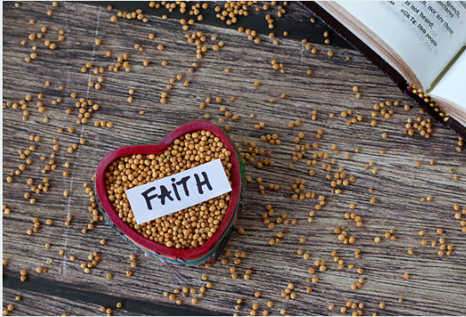
Sunday, October 19, 2025
Welcome & Announcements Phil Morgan
Greeting of the Fellowship
Prelude Jaci Greig
*Gathering Hymn Praise to the Lord, The Almighty #210 (vs 1,2 &4)
*Call to Worship Phil Morgan
Leader: Come, listen to the story
People: Of God’s love and grace.
Leader: Come, tell the story
People: Of Jesus’ life and saving work.
Leader: Come, experience the story
People: Of the Spirit’s renewing power.
All: Come, let us listen, tell and experience the good news together!

*Invocation and Lord’s Prayer (We use “sins”) Phil Morgan
Hymn How Great Thou Art #147 (vs 1,3 & 4)
Scripture Reading Psalm 121 Phil Morgan
One: Hear what God is saying to the people
Many: Thanks be to God!

Worship Prayer Pastor Dianna Cline
Prayer Song Cares Chorus
Prayer (During the prayer you will have the opportunity to call out concerns and praises)

*Hymn Blessed Assurance #572

Scripture Reflection Luke 18:1-8 Pastor Dianna Cline
“Praying with Persistence”

*Hymn of Response Leaning on the Everlasting Arms #575
(This is a time to come forward to join the church, rededicate your life, or be baptized)

Invitation to Respond Phil Morgan

Offertory
*Doxology
*Prayer Pastor Dianna Cline
Benediction
Postlude Jaci Greig

Lay Leader: Phil Morgan
Pianist: Jaci Greig
Today’s Ushers: Patty Dammann and Pat Morgan

October flowers for the Sanctuary done by Melody Lynch

CONTACT INFORMATION
New Bethel Baptist Church Website: www.newbethelbapt.org
8936 Southeastern Avenue E-mail: newbethelbapt@att.net Indianapolis, IN 46239 Wi-fi password: NBBC8624381
317-862-4381
Worship Music Copyright and Live-Streaming Permissions
All selections ©1997 Word/Integrity Used by Permission.
CCLI License #1631733

Live-Streaming: CCS, WorshipCast, License #10868

