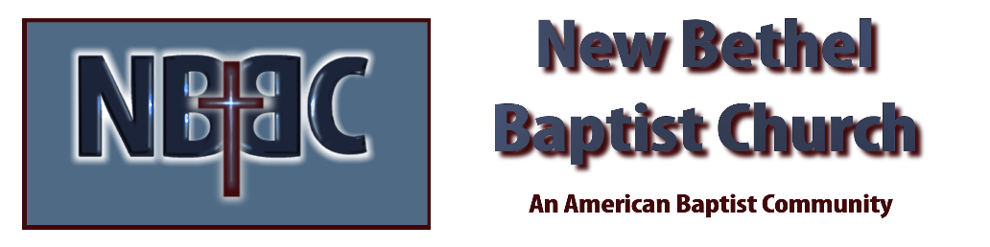
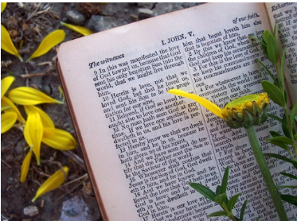
Sunday, October 26, 2025
Welcome & Announcements Phil Morgan
Greeting of the Fellowship
Prelude Jaci Greig
*Gathering Hymn Come into His Presence #171 (2x’s)
*Call to Worship Phil Morgan
Leader: Are you weary, worn out, tired?
All: Yes, my soul, find rest in God; my hope comes from him.
Leader: Do you feel frail, weak and uncertain of your future?
All: Truly God is my rock and my salvation; he is my fortress; I will not be shaken.
Leader: Are you trusting in your own strength?
All: My salvation and my honor depend on God; he is my mighty rock, my refuge.
Leader: Trust in him at all times, you people; pour out your hearts to him, for God is our refuge.
*Invocation and Lord’s Prayer (We use “sins”) Phil Morgan
Hymn Lord, Be Glorified #186
Scripture Reading Psalm 84:1-7 Phil Morgan
One: Hear what God is saying to the people
Many: Thanks be to God!

Worship Prayer Pastor Dianna Cline
Prayer Song Cares Chorus
Prayer (During the prayer you will have the opportunity to call out concerns and praises)

*Hymn Alleluia #189 (vs.1 & 4)

Scripture Reflection Joel 2:23-32 Pastor Dianna Cline
“Keeping the Faith”

*Hymn of Response Faith is the Victory #727 (vs. 1,2 & 4)
(This is a time to come forward to join the church, rededicate your life, or be baptized)

Invitation to Respond Phil Morgan

Offertory
*Doxology
*Prayer Pastor Dianna Cline
Benediction
Postlude Jaci Greig

Lay Leader: Phil Morgan
Pianist: Jaci Greig
Today’s Ushers: Liz Ballard and Greg West

October flowers for the Sanctuary done by Melody Lynch

CONTACT INFORMATION
New Bethel Baptist Church Website: www.newbethelbapt.org
8936 Southeastern Avenue E-mail: newbethelbapt@att.net Indianapolis, IN 46239 Wi-fi password: NBBC8624381
317-862-4381
Worship Music Copyright and Live-Streaming Permissions
All selections ©1997 Word/Integrity Used by Permission.
CCLI License #1631733

Live-Streaming: CCS, WorshipCast, License #10868

