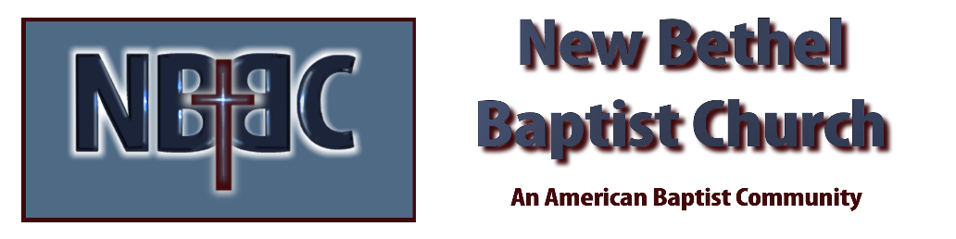
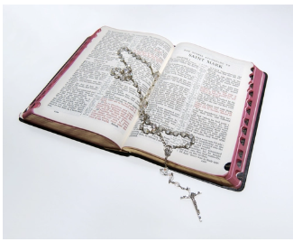
Sunday, November 2, 2025
Welcome & Announcements Phil Morgan
Greeting of the Fellowship
Prelude Jaci Greig
*Gathering Hymn We Have Come into His House #224
*Call to Worship Phil Morgan
Leader: If with all your hearts you truly seek me, you shall surely find me: thus saith the Lord.
People: Draw near to God, and God will draw near to you.
ALL: Humble yourselves before the Lord, and he will exalt you.

*Invocation and Lord’s Prayer (We use “sins”) Phil Morgan
Hymn Seek Ye First #713
Scripture Reading Psalm 32:1-7 Phil Morgan
One: Hear what God is saying to the people
Many: Thanks be to God!

Worship Prayer Pastor Dianna Cline
Prayer Song Cares Chorus
Prayer (During the prayer you will have the opportunity to call out concerns and praises)

*Hymn Great is thy Faithfulness #139

Scripture Reflection Luke 19:1-10 Pastor Dianna Cline
“No Hiding Place”

*Hymn of Response I surrender All #596 (vs. 1 & 4)
(This is a time to come forward to join the church, rededicate your life, or be baptized)

Invitation to Respond Phil Morgan

Offertory
*Doxology
*Prayer Pastor Dianna Cline
Communion Hymn Come to the Table #464
Communion
Benediction Blest be the Tie #426
Postlude Jaci Greig

Lay Leader: Phil Morgan
Pianist: Jaci Greig
Today’s Ushers: Donna Carnes and Patrick Lynch
Deacons: Adrianne and Jim

CONTACT INFORMATION
New Bethel Baptist Church Website: www.newbethelbapt.org
8936 Southeastern Avenue E-mail: newbethelbapt@att.net Indianapolis, IN 46239 Wi-fi password: NBBC8624381
317-862-4381
Worship Music Copyright and Live-Streaming Permissions
All selections ©1997 Word/Integrity Used by Permission.
CCLI License #1631733

Live-Streaming: CCS, WorshipCast, License #10868

