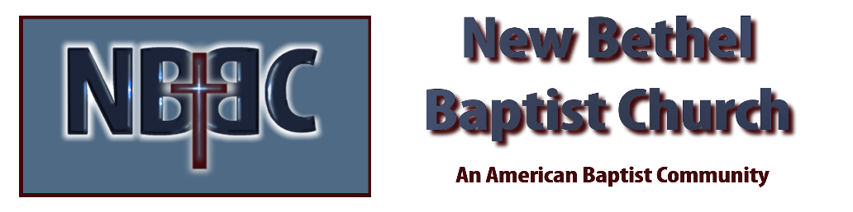
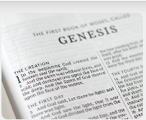
Sunday, November 16, 2025
Welcome & Announcements Adrianne Hunter
Greeting of the Fellowship
Prelude Jaci Greig
*Gathering Hymn Great is the Lord #140
*Call to Worship Adrianne Hunter
Leader: Great is the Lord and greatly to be praised! One generation shall extol your works to another,
People: We shall declare your mighty acts.
Leader: They will recount the glorious splendor of your majesty,
People: On your wondrous works we will meditate.
Leader: They will proclaim the might of your awesome deeds,
People: We will declare your greatness.
Leader: They shall celebrate the fame of your abundant goodness,
People: We shall sing aloud of your righteousness.
—Based on Psalm 145

*Invocation and Lord’s Prayer (We use “sins”) Adrianne Hunter
Hymn Name of All Majesty #116

Scripture Reading Psalm 98 Adrianne Hunter
One: Hear what God is saying to the people
Many: Thanks be to God!

Worship Prayer Pastor Dianna Cline
Prayer Song Cares Chorus
Prayer (During the prayer you will have the opportunity to call out concerns and praises)

*Hymn Be Thou my Vision #562

Scripture Reflection Isaiah 65:17-25 Pastor Dianna Cline
“Old Age”

*Hymn of Response Make Me a Servant #669
(This is a time to come forward to join the church, rededicate your life, or be baptized)

Invitation to Respond Adrianne Hunter

Offertory
*Doxology
*Prayer Pastor Dianna Cline
Benediction
Postlude Jaci Greig

Lay Leader: Adrianne Hunter
Pianist: Jaci Greig
Today’s Ushers: Patty Dammann and Pat Morgan

CONTACT INFORMATION
New Bethel Baptist Church Website: www.newbethelbapt.org
8936 Southeastern Avenue E-mail: newbethelbapt@att.net Indianapolis, IN 46239 Wi-fi password: NBBC8624381
317-862-4381
Worship Music Copyright and Live-Streaming Permissions
All selections ©1997 Word/Integrity Used by Permission.
CCLI License #1631733

Live-Streaming: CCS, WorshipCast, License #10868

