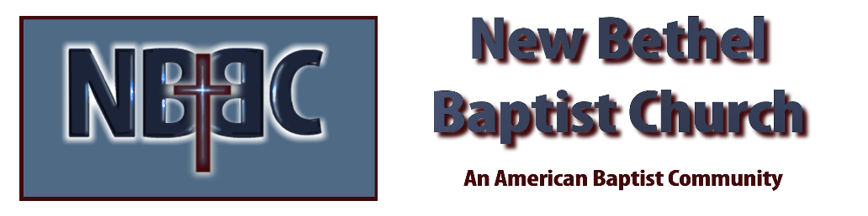

Sunday, November 30, 2025

Welcome & Announcements Phil Morgan
Prelude Jaci Greig
*Gathering Hymn Come, Christians Join to Sing #225
Advent Reading/Candle Lighting
Lord’s Prayer (We use “sins”) Phil Morgan
Hymn O Come, O Come, Emmanuel #245

Scripture Reading Psalm 122 Phil Morgan
One: Hear what God is saying to the people
Many: Thanks be to God!

Worship Prayer Pastor Dianna Cline
Prayer Song Cares Chorus
Prayer (During the prayer you will have the opportunity to call out concerns and praises)

*Hymn Come, Thou Long-Expected Jesus #244

Scripture Reflection Isaiah 2:1-5 Pastor Dianna Cline
“Hopeful Pessimism”

*Hymn of Response My Life is in You, Lord #542
(This is a time to come forward to join the church, rededicate your life, or be baptized)

Invitation to Respond Phil Morgan

Offertory Special Music by NBBC Choir
*Doxology
*Prayer Pastor Dianna Cline
Benediction
Postlude Jaci Greig

Advent Readers: Ruth Ann Mills and Liz Ballard
Lay Leader: Phil Morgan
Pianist: Jaci Greig
Today’s Ushers: Sue and Jim

CONTACT INFORMATION
New Bethel Baptist Church Website: www.newbethelbapt.org
8936 Southeastern Avenue E-mail: newbethelbapt@att.net Indianapolis, IN 46239 Wi-fi password: NBBC8624381
317-862-4381
Worship Music Copyright and Live-Streaming Permissions
All selections ©1997 Word/Integrity Used by Permission.
CCLI License #1631733

Live-Streaming: CCS, WorshipCast, License #10868

