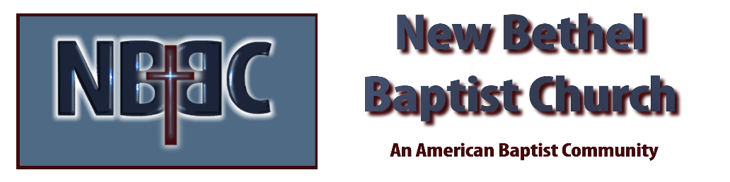

Sunday, December 7, 2025

Welcome & Announcements Phil Morgan
Prelude Jaci Greig
*Gathering Hymn Let’s Worship and Adore Him #247
Advent Reading/Candle Lighting
Lord’s Prayer (We use “sins”) Phil and Pat Morgan
Hymn I Heard the Bells on Christmas Day #267

Scripture Reading Isaiah 11:1-10 Phil Morgan
One: Hear what God is saying to the people
Many: Thanks be to God!

Worship Prayer Pastor Dianna Cline
Prayer Song Cares Chorus
Prayer (During the prayer you will have the opportunity to call out concerns and praises)

*Hymn Sunshine in My Soul #747

Scripture Reflection Romans 15:4-13 Pastor Dianna Cline
“Peace”

*Hymn of Response Special music by John Huddleston and Patty Damman
(This is a time to come forward to join the church, rededicate your life, or be baptized)

Invitation to Respond Phil Morgan

Offertory
*Doxology
*Prayer Pastor Dianna Cline
Communion Hymn Come to the Table #464
Communion
Benediction
Postlude Jaci Greig

Lay Leader: Phil Morgan
Pianist: Jaci Greig
Today’s Ushers: Donna Carnes and Patrick Lynch
Deacons: Jim and Ruth Ann

CONTACT INFORMATION
New Bethel Baptist Church Website: www.newbethelbapt.org
8936 Southeastern Avenue E-mail: newbethelbapt@att.net Indianapolis, IN 46239 Wi-fi password: NBBC8624381
317-862-4381
Worship Music Copyright and Live-Streaming Permissions
All selections ©1997 Word/Integrity Used by Permission.
CCLI License #1631733

Live-Streaming: CCS, WorshipCast, License #10868

