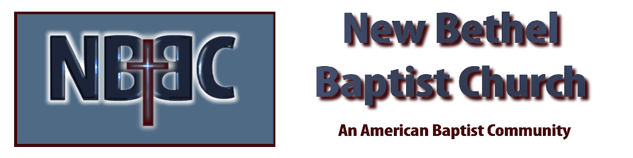

Sunday, December 21, 2025

Welcome & Announcements Phil Morgan
Greeting of the Fellowship

Prelude Jaci Greig
*Gathering Hymn Hark! the Herald Angels Sing #277
Advent Reading/Candle Lighting
Lord’s Prayer (We use “sins”) Phil and Pat Morgan

Hymn Love Has Come! #256

Worship Prayer Pastor Dianna Cline
Prayer Song Cares Chorus
Prayer (During the prayer you will have the opportunity to call out concerns and praises)

*Hymn Of the Father’s Love Begotten #240

Scripture Reflection Matthew 1:18-25 Pastor Dianna Cline
“Love”

*Hymn of Response I Give All to You #595
(This is a time to come forward to join the church, rededicate your life, or be baptized)

Invitation to Respond Phil Morgan

Offertory Special Music by Kevin Stone and Phil Morgan
*Doxology
*Prayer Pastor Dianna Cline
Benediction
Postlude Jaci Greig

Lay Leader: Phil Morgan
Pianist: Jaci Greig
Today’s Ushers: Patty Dammann and Pat Morgan

CONTACT INFORMATION
New Bethel Baptist Church Website: www.newbethelbapt.org
8936 Southeastern Avenue E-mail: newbethelbapt@att.net Indianapolis, IN 46239 Wi-fi password: NBBC8624381
317-862-4381
Worship Music Copyright and Live-Streaming Permissions
All selections ©1997 Word/Integrity Used by Permission.
CCLI License #1631733

Live-Streaming: CCS, WorshipCast, License #10868

