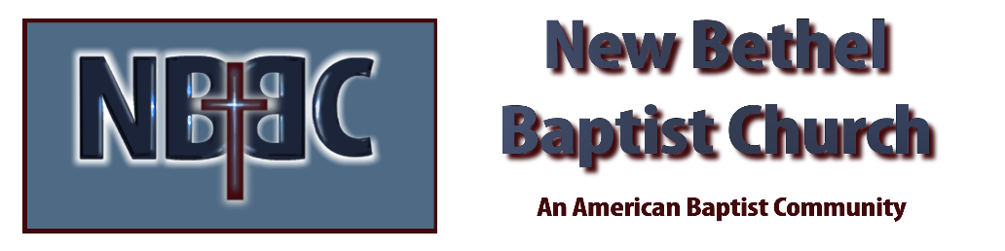
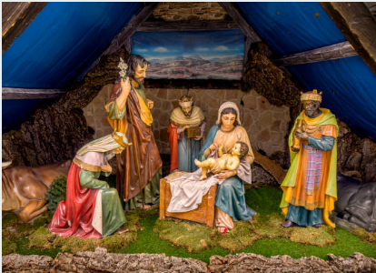
Wednesday, December 24, 2025
Merry Christmas

Prelude Jaci Greig
*Gathering Hymn It Came upon the Midnight Clear #251
Advent Reading/Candle Lighting
Lord’s Prayer (We use “sins”)
Hymn Away in a Manger #261

Scripture Reading Isaiah 9:2-7
One: Hear what God is saying to the people
Many: Thanks be to God!

Worship Prayer Pastor Dianna Cline
Prayer Song Cares Chorus
Prayer (During the prayer you will have the opportunity to call out concerns and praises)

*Hymn O Little Town of Bethlehem #250

Scripture Reflection Luke 2:1-20 Pastor Dianna Cline
“The Gift”

*Hymn of Response Angels, from the Realms of Glory #259
(This is a time to come forward to join the church, rededicate your life, or be baptized)

Invitation to Respond

Offertory
*Doxology
*Prayer Pastor Dianna Cline

Communion Hymn #287
Communion Litany Pastor Dianna Cline
Pastor: The peace of the Lord be with you.
People: and also with you.
Pastor: Lift up your hearts
People: We lift them up to the Lord
Pastor: Let us give thanks to the Lord our God
People: It is right to give God thanks and praise

Communion Pastor Dianna Cline and Deacons

Benediction Sing Silent Night while lighting each other’s candles #253
Postlude Jaci Greig

Lay Leader:
Pianist: Jaci Greig

CONTACT INFORMATION
New Bethel Baptist Church Website: www.newbethelbapt.org
8936 Southeastern Avenue E-mail: newbethelbapt@att.net Indianapolis, IN 46239 Wi-fi password: NBBC8624381
317-862-4381
Worship Music Copyright and Live-Streaming Permissions
All selections ©1997 Word/Integrity Used by Permission.
CCLI License #1631733

Live-Streaming: CCS, WorshipCast, License #10868

