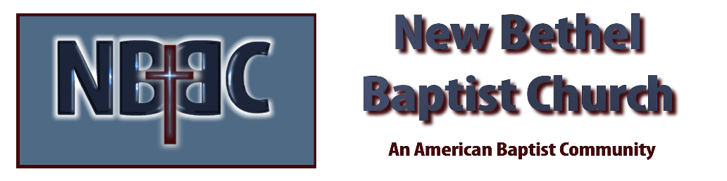
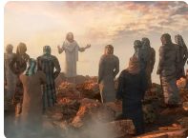
Sunday, January 18, 2026
Welcome & Announcements Phil Morgan
Greeting of the Fellowship
Prelude Jaci Greig
*Gathering Hymn Come, Christian, Join to Sing #225
*Call to Worship
Leader: Christ is calling, inviting, urging and wooing: Come and follow me!
People: Let us set aside our worry and fear, our busyness and competing agendas to respond to Christ’s call.
Leader: Christ offers us the opportunity to walk with him, to come to know his heart more deeply day by day.
People: Nothing is more precious than opening our hearts to God, who fills us with love.
Leader: Christ grants us the privilege of working alongside him in our Father’s business.
People: There is no higher call and no greater joy than making a difference in the kingdom of God.
Leader: Come, let us worship the One who calls us to follow!
People: We worship in joy, in gratitude, in praise: Jesus Christ is Lord of all!

*Invocation and Lord’s Prayer (We use “sins”) Phil Morgan
Hymn Jesus, I come #491
Scripture Reading Psalm 40:1-11 Phil Morgan
One: Hear what God is saying to the people
Many: Thanks be to God!

Worship Prayer Pastor Dianna Cline
Prayer Song Cares Chorus
Prayer (During the prayer you will have the opportunity to call out concerns and praises)

*Hymn Come, Ye Sinners, Poor and Needy #486

Scripture Reflection John 1:29-42 Pastor Dianna Cline
“Come and See”

*Hymn of Response Just as I am #488
(This is a time to come forward to join the church, rededicate your life, or be baptized)

Invitation to Respond Phil Morgan

Offertory
*Doxology
*Prayer Pastor Dianna Cline
Benediction
Postlude Jaci Greig

Lay Leader: Phil Morgan
Pianist: Jaci Greig
Today’s Ushers: Patty Dammann and Pat Morgan

CONTACT INFORMATION
New Bethel Baptist Church Website: www.newbethelbapt.org
8936 Southeastern Avenue E-mail: newbethelbapt@att.net Indianapolis, IN 46239 Wi-fi password: NBBC8624381
317-862-4381
Worship Music Copyright and Live-Streaming Permissions
All selections ©1997 Word/Integrity Used by Permission.
CCLI License #1631733

Live-Streaming: CCS, WorshipCast, License #10868

