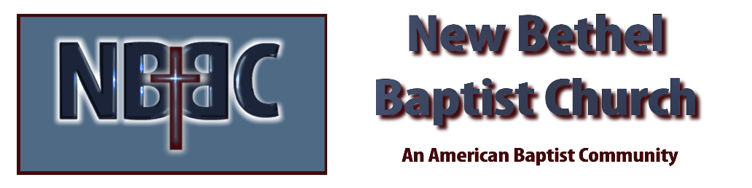

Sunday, January 4, 2026
Welcome & Announcements Phil Morgan
Greeting of the Fellowship
Prelude Jaci Greig
*Gathering Hymn Let’s Just Praise the Lord #18
*Call to Worship Page 19 in the Hymnal Phil Morgan

*Invocation and Lord’s Prayer (We use “sins”) Phil Morgan
Hymn Majesty #10

Scripture Reading Jeremiah 31:7-14 Phil Morgan
One: Hear what God is saying to the people
Many: Thanks be to God!

Worship Prayer Pastor Dianna Cline
Prayer Song Cares Chorus
Prayer (During the prayer you will have the opportunity to call out concerns and praises)

*Hymn O How I Love Jesus #92

Scripture Reflection Psalm 147:12-20 Pastor Dianna Cline
“Steps to improve our relationship with our Creator”

*Hymn of Response I Love you Lord #78
(This is a time to come forward to join the church, rededicate your life, or be baptized)

Invitation to Respond Phil Morgan

Offertory
*Doxology
*Prayer Pastor Dianna Cline

Communion Hymn In Remembrance #461
Communion
Benediction Blest Be the Tie #426
Postlude Jaci Greig

Lay Leader: Phil Morgan
Pianist: Jaci Greig
Today’s Ushers: Donna Carnes and Patrick Lynch
Deacons: Ruth Ann and Sherry

CONTACT INFORMATION
New Bethel Baptist Church Website: www.newbethelbapt.org
8936 Southeastern Avenue E-mail: newbethelbapt@att.net Indianapolis, IN 46239 Wi-fi password: NBBC8624381
317-862-4381
Worship Music Copyright and Live-Streaming Permissions
All selections ©1997 Word/Integrity Used by Permission.
CCLI License #1631733

Live-Streaming: CCS, WorshipCast, License #10868

