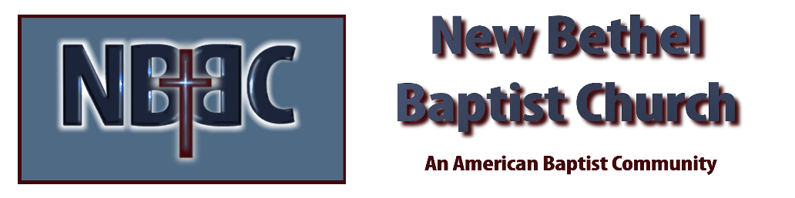

Sunday, February 1, 2026
Welcome & Announcements Phil Morgan
Greeting of the Fellowship
Prelude Jaci Greig
*Gathering Hymn We Have Come to Join in Worship #207
*Call to Worship

Leader: We are a holy tapestry of mystery and meaning,
People: A fine garment of divine blessing and human care,
Leader: A gentle weave of deep sighs and fervent prayers,
People: A piece of art woven with whispers and exclamation points,
Leader: We are God's tapestry --
People: Touched with mystery and filled with meaning.

*Invocation and Lord’s Prayer (We use “sins”) Phil Morgan
Hymn Cleanse Me #657
Scripture Reading Psalm 15 (NIV) Phil Morgan
One: Hear what God is saying to the people
Many: Thanks be to God!

Worship Prayer Pastor Dianna Cline
Prayer Song Cares Chorus
Prayer (During the prayer you will have the opportunity to call out concerns and praises)

*Hymn Blessed Assurance #572

Scripture Reflection Matthew 5:1-12 Pastor Dianna Cline
“Are you Blessed?”

*Hymn of Response Take My Life and Let it Be Consecrated (Verses 1,5 & 6)
(This is a time to come forward to join the church, rededicate your life, or be baptized)

Invitation to Respond Phil Morgan

Offertory
*Doxology
*Prayer Pastor Dianna Cline
Communion Hymn Come to the Table #464
Communion
Benediction Blest Be the Tie #426
Postlude Jaci Greig

Lay Leader: Phil Morgan
Pianist: Jaci Greig
Today’s Ushers: Donna Carnes and Patrick Lynch
Deacons: Sherry and Sue

CONTACT INFORMATION
New Bethel Baptist Church Website: www.newbethelbapt.org
8936 Southeastern Avenue E-mail: newbethelbapt@att.net Indianapolis, IN 46239 Wi-fi password: NBBC8624381
317-862-4381
Worship Music Copyright and Live-Streaming Permissions
All selections ©1997 Word/Integrity Used by Permission.
CCLI License #1631733

Live-Streaming: CCS, WorshipCast, License #10868

