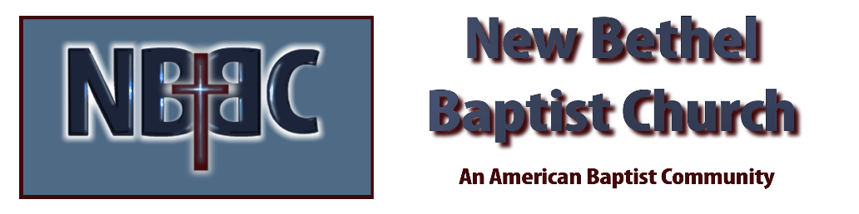
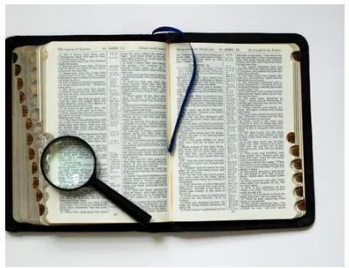
Sunday, February 8, 2026
Welcome & Announcements Phil Morgan
Greeting of the Fellowship
Prelude Jaci Greig
*Gathering Hymn We Have Come into His House #224
*Call to Worship

Leader: Jesus said, “I am the light of the world.”
People: We are gathered in your house, O God, to celebrate the light.
Leader: Jesus said, “Whoever follows me will never walk in darkness but will have the light of life.”
People: We praise you, Lord Jesus, for illuminating our path and helping us master our fear of the dark, even of the dark tunnel of death.
Leader: Jesus said, “You are the light of the world … let your light shine before others, so that they may see your good works and give glory to your Father in heaven.”
People: Spirit of God, empower our witness to the Light, in this service of worship and in our whole beings, as women and men claimed by the Light. Amen.

*Invocation and Lord’s Prayer (We use “sins”) Phil Morgan
Hymn Shine, Jesus, Shine #431
Scripture Reading Psalm 112:1-9 Phil Morgan
One: Hear what God is saying to the people
Many: Thanks be to God!

Worship Prayer Pastor Dianna Cline
Prayer Song Cares Chorus
Prayer (During the prayer you will have the opportunity to call out concerns and praises)

*Hymn Send the Light #437

Scripture Reflection Matthew 5:13-20 Pastor Dianna Cline
“Shine the Light!”

*Hymn of Response Saved, Saved! #500
(This is a time to come forward to join the church, rededicate your life, or be baptized)

Invitation to Respond Phil Morgan

Offertory
*Doxology
*Prayer Pastor Dianna Cline
Benediction
Postlude Jaci Greig

Lay Leader: Phil Morgan
Pianist: Jaci Greig
Today’s Ushers: Jeannine Toon and Sherry Shoemaker

CONTACT INFORMATION
New Bethel Baptist Church Website: www.newbethelbapt.org
8936 Southeastern Avenue E-mail: newbethelbapt@att.net Indianapolis, IN 46239 Wi-fi password: NBBC8624381
317-862-4381
Worship Music Copyright and Live-Streaming Permissions
All selections ©1997 Word/Integrity Used by Permission.
CCLI License #1631733

Live-Streaming: CCS, WorshipCast, License #10868

