Welcome to New Bethel Baptist Church
Sunday February 15, 2026

Welcome & Announcements Phil Morgan
Greeting of the Fellowship

Prelude Jaci Greig

*Gathering Hymn Let’s Just Praise the Lord #18 (sing 2X’s)

*Call to Worship Phil Morgan
Leader: God of life, once more you have called us together for worship.
Many: We have come to be refreshed.
Leader: We have come to be reminded of whose we are.
Many: We have come to explore who and how you are calling us to be in the world.
Leader: God of light, in this time together, open our eyes, our hearts and our very beings to see, hear and feel how you are active in our midst.
Many: God of love, who calls us to live love, may the time we spend listening for your still, small voice awaken an awareness of how we can put love into action and how we can care for all our relationships. We pray in the name of Jesus.

*Invocation and Lord’s Prayer (We use “sins”) Phil Morgan

Hymn The Bond of Love #423

Scripture Reading Psalm 99 Phil Morgan
One: Hear what God is saying to the people
Many: Thanks be to God!

Worship Prayer Pastor Dianna Cline
Prayer Song Cares Chorus
Prayer (During the prayer you will have the opportunity to call out concerns and praises)

*Hymn Love Lifted Me #508

Scripture Reflection 2 Peter 1:16-21 Pastor Dianna Cline
“The Morning Star”

*Hymn of Response They’ll Know We Are Christians #429

Invitation to Respond Phil Morgan
Offertory Jaci Greig
*Doxology
*Prayer Pastor Dianna Cline

If you are seeking bap'sm, to become a member at New Bethel, or would like someone to pray
with you, you are invited to come forward during this hymn.
If you are seeking bap'sm, to become a member at New Bethel, or would like someone to pray
with you, you are invited to come forward during this hymn.
Benediction Pastor Dianna Cline
Postlude Jaci Greig

Lay Leader: Phil Morgan
Pianist: Jaci Greig
Today’s Ushers: Patty Dammann & Pat Morgan

CONTACT INFORMATION
New Bethel Baptist Church Website: www.newbethelbapt.org
8936 Southeastern Avenue E-mail: newbethelbapt@att.net
Indianapolis, IN 46239 Wi-fi password: NBBC8624381
317-862-4381

Worship Music Copyright and Live-Streaming Permissions
All selections ©1997 Word/Integrity Used by Permission.
CCLI License #1631733
Live-Streaming: CCS, WorshipCast, License #10868

Here is Frost’s take on what stars have to teach us:

O Star (the fairest one in sight),
We grant your loftiness the right
To some obscurity of cloud —
It will not do to say of night,
Since dark is what brings out your light.
Some mystery becomes the proud,
But to be wholly taciturn
In your reserve is not allowed.
Say something to us we can learn
By heart and when alone repeat.
Say something! And it says, ‘I burn.’
But say with what degree of heat.
Talk Fahrenheit, talk Centigrade.
Use language we can comprehend.
Tell us what elements you blend.
It gives us strangely little aid,
But does tell something in the end.
And steadfast as Keats’ Eremite,
Not even stooping from its sphere,
It asks a little of us here.
It asks of us a certain height,
So when at times the mob is swayed
To carry praise or blame too far,
We may choose something like a star
To stay our minds on and be staid

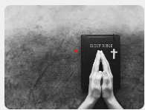
,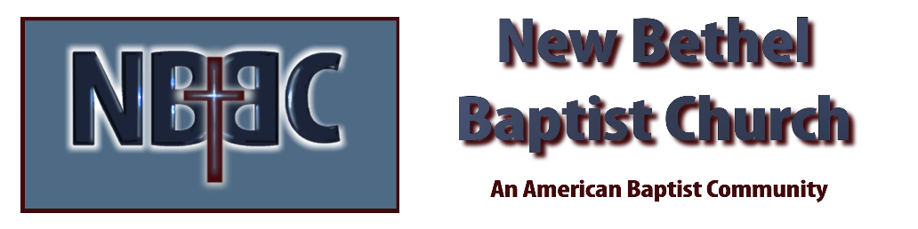

Sunday February 15, 2026



