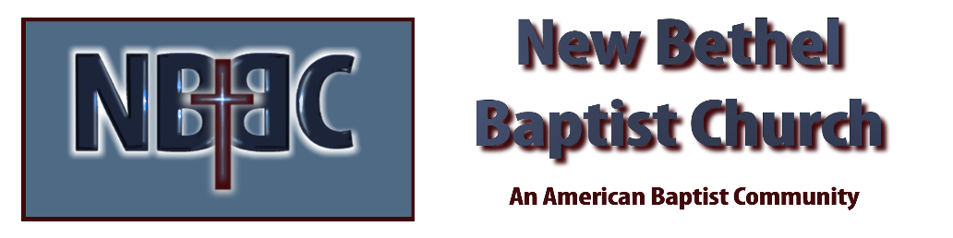

Sunday, March 15, 2026
Welcome & Announcements Phil Morgan
Greeting of the Fellowship
Prelude Jaci Greig
*Gathering Hymn We Have Come to Join in Worship #207
*Call to Worship
Leader: The Lord, our God, chose us.
People: We are chosen to live a life of love.
All: He has commissioned us to love one another as he loves us.

*Invocation and Lord’s Prayer (We use “sins”) Phil Morgan
Hymn The Bond of Love #423
Scripture Reading Psalm 23 Phil Morgan
One: Hear what God is saying to the people
Many: Thanks be to God!

Worship Prayer Pastor Dianna Cline
Prayer Song Cares Chorus
Prayer (During the prayer you will have the opportunity to call out concerns and praises)

*Hymn I’ll Live for Him #590

Scripture Reflection 1 Samuel 16:1-13 Pastor Dianna Cline
“God’s Selection Process”

*Hymn of Response Heaven Came Down #510
(This is a time to come forward to join the church, rededicate your life, or be baptized)

Invitation to Respond Phil Morgan

Offertory
*Doxology
*Prayer Pastor Dianna Cline
Benediction
Postlude Jaci Greig

Lay Leader: Phil Morgan
Pianist: Jaci Greig
Today’s Ushers: Patty Dammann and Pat Morgan

CONTACT INFORMATION
New Bethel Baptist Church Website: www.newbethelbapt.org
8936 Southeastern Avenue E-mail: newbethelbapt@att.net Indianapolis, IN 46239 Wi-fi password: NBBC8624381
317-862-4381
Worship Music Copyright and Live-Streaming Permissions
All selections ©1997 Word/Integrity Used by Permission.
CCLI License #1631733

Live-Streaming: CCS, WorshipCast, License #10868

