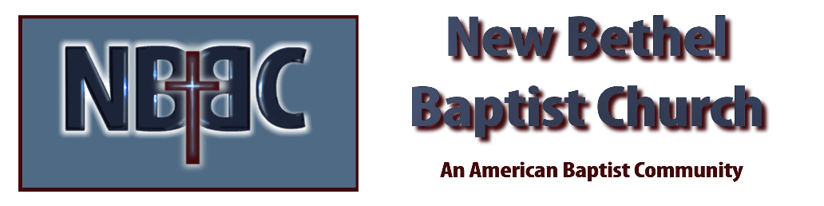
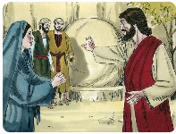
Sunday, March 22, 2026
Welcome & Announcements Phil Morgan
Greeting of the Fellowship
Prelude Dr. Christina Romero
*Gathering Hymn O for a Thousand Tongues to Sing #21 (vs. 1,2,3 & 5)
*Call to Worship
One: Day after day, an abundance of God’s love,
All: Morning by morning, new signs of blessing:
One: A gentle rain, an awesome sunset,
All: A friend’s embrace, a child’s smile,
One: A new insight, a sense of peace,
All: A shared meal, a treasured moment.
One: All around us and deep within us are signs of God’s presence.
All: How can we not sing of God’s faithfulness?

*Invocation and Lord’s Prayer (We use “sins”) Phil Morgan
Hymn Great Is Thy Faithfulness #139
Scripture Reading John 11:1-16 Phil Morgan
One: Hear what God is saying to the people
Many: Thanks be to God
Worship Prayer Pastor Dianna Cline
Prayer Song Cares Chorus
Prayer (During the prayer you will have the opportunity to call out concerns and praises)

*Hymn Breathe on Me, Breath of God #393

Scripture Reflection John 11:17-45 Pastor Dianna Cline
“The Raising of Lazarus”

*Hymn of Response There Is Power in the Blood #329
(This is a time to come forward to join the church, rededicate your life, or be baptized)

Invitation to Respond Phil Morgan

Offertory
*Doxology
*Prayer Pastor Dianna Cline
Benediction
Postlude Dr. Christina Romero

Lay Leader: Phil Morgan
Pianist: Dr. Christina Romero
Today’s Ushers: Liz Ballard and Greg West

CONTACT INFORMATION
New Bethel Baptist Church Website: www.newbethelbapt.org
8936 Southeastern Avenue E-mail: newbethelbapt@att.net Indianapolis, IN 46239 Wi-fi password: NBBC8624381
317-862-4381
Worship Music Copyright and Live-Streaming Permissions
All selections ©1997 Word/Integrity Used by Permission.
CCLI License #1631733

Live-Streaming: CCS, WorshipCast, License #10868

