
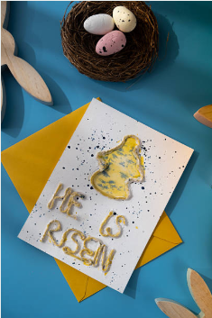
Sunday, March 29, 2026
Welcome & Announcements Phil Morgan
Greeting of the Fellowship
Prelude Jaci Greig
*Gathering Hymn Hosanna, Loud Hosanna #297
*Call to Worship
Leader: This is the day God has made; let us rejoice and be glad in it.
People: Give thanks to the Lord, for he is good; his steadfast love endures forever!
Leader: Blessed is the one who comes in the name of the Lord.
People: Open to us the gates of righteousness, that we may enter through them and give thanks.
Leader: Here is the gate; come, let the righteous enter. Bring your branches to the festival procession.
People: This is your day of triumph, God. This day is your doing; it is marvelous in our eyes.
Leader: Give thanks to the Lord, for he is good; his steadfast love endures forever!
People: This is the day God has made; let us rejoice and be glad in it.
—Based on Psalm 118:1-2, 19-29
*Invocation and Lord’s Prayer (We use “sins”) Phil Morgan
Hymn This Is the Day #209
Scripture Reading Matthew 21:1-11 Phil Morgan
One: Hear what God is saying to the people
Many: Thanks be to God
Worship Prayer Pastor Dianna Cline
Prayer Song Cares Chorus
Prayer (During the prayer you will have the opportunity to call out concerns and praises)

*Hymn Wonderful Words of Life #406

Scripture Reflection Psalm 118:1-2, 19-29 Pastor Dianna Cline
“The King they got vs. the One they expected”

*Hymn of Response Jesus Paid It All #305
(This is a time to come forward to join the church, rededicate your life, or be baptized)

Invitation to Respond Phil Morgan

Offertory
*Doxology
*Prayer Pastor Dianna Cline
Benediction
Postlude Jaci Greig

Lay Leader: Phil Morgan
Pianist: Jaci Greig
Today’s Ushers: Sue and Jim

CONTACT INFORMATION
New Bethel Baptist Church Website: www.newbethelbapt.org
8936 Southeastern Avenue E-mail: newbethelbapt@att.net Indianapolis, IN 46239 Wi-fi password: NBBC8624381
317-862-4381
Worship Music Copyright and Live-Streaming Permissions
All selections ©1997 Word/Integrity Used by Permission.
CCLI License #1631733

Live-Streaming: CCS, WorshipCast, License #10868

