
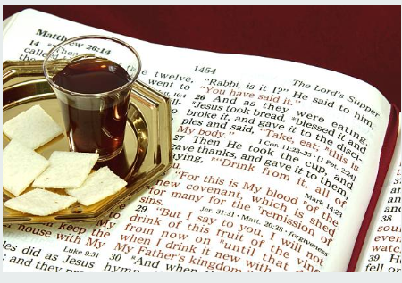
Sunday, March 8, 2026
Welcome & Announcements Phil Morgan
Greeting of the Fellowship
Prelude Jaci Greig
*Gathering Hymn Come, Christians, Join to Sing #225
*Call to Worship
One: We are looking for paradise here on Earth.
All: We are searching for a love that lasts.
One: We yearn for a glimpse of God.
All: We thirst for the fountain of life.
One: We hunger for lasting joy.
All: Our hearts ache for something more.
One: Bring all your hopes and longings to this place, for God is big enough to hold us all.
All: God’s love embraces us, calms us and strengthens us. God’s grace surprises us and causes us to sing.

*Invocation and Lord’s Prayer (We use “sins”) Phil Morgan
Hymn Grace Greater than Our Sin #344 (vs. 1,2 & 4)
Scripture Reading John 4:5-26 Phil Morgan
One: Hear what God is saying to the people
Many: Thanks be to God!

Worship Prayer Pastor Dianna Cline
Prayer Song Cares Chorus
Prayer (During the prayer you will have the opportunity to call out concerns and praises)

*Hymn All the Way My Savior Leads Me #680

Scripture Reflection John 4:27-42 Pastor Dianna Cline
“Worship and breaking bread together”

*Hymn of Response Sweet, Sweet Spirit #391
(This is a time to come forward to join the church, rededicate your life, or be baptized)

Invitation to Respond Phil Morgan

Offertory
*Doxology
*Prayer Pastor Dianna Cline
Benediction
Postlude Jaci Greig

Lay Leader: Phil Morgan
Pianist: Jaci Greig
Today’s Ushers: Jeannine Toon and Sherry Shoemaker

CONTACT INFORMATION
New Bethel Baptist Church Website: www.newbethelbapt.org
8936 Southeastern Avenue E-mail: newbethelbapt@att.net Indianapolis, IN 46239 Wi-fi password: NBBC8624381
317-862-4381
Worship Music Copyright and Live-Streaming Permissions
All selections ©1997 Word/Integrity Used by Permission.
CCLI License #1631733

Live-Streaming: CCS, WorshipCast, License #10868

