Welcome to New Bethel Baptist Church
Sunday April 12, 2026

Prelude Jaci Greig
Welcome & Announcements Phil Morgan
Greeting of the Fellowship
*Gathering Hymn Come, Christians, Join to Sing #225
*Call to Worship Phil Morgan
Leader: God is waiting for us
People: With a tender heart and a searching question.
Leader: God is ready for us
People: With truth and wisdom from a deep well.
Leader: God is blessing us
People: With springs of living water.
Leader: God is sending us
People: To sing, pray and witness every day.
Leader: God is here.
People: Let the conversation begin.

*Invocation and Lord’s Prayer (We use “sins”) Phil Morgan
Hymn Near to the Heart of God #617

Scripture Reading Psalm 16 Phil Morgan
One: Hear what God is saying to the people
Many: Thanks be to God!

Worship Prayer Pastor Dianna Cline
Prayer Song Cares Chorus
Prayer (During the prayer you will have the opportunity to call out concerns and praises)

*Hymn Wonderful Words of Life #406

Scripture Reflection Acts 2:14A, 22-32 Pastor Dianna Cline
“The Bible still speaks to us”

*Hymn of Response Standing on the Promises #410
(This is a time to come forward to join the church, rededicate your life, or be baptized)

Invitation to Respond Phil Morgan
Offertory Jaci Greig
*Doxology
*Prayer Pastor Dianna Cline
If you are seeking bap'sm, to become a member at New Bethel, or would like someone to pray
with you, you are invited to come forward during this hymn.
If you are seeking bap'sm, to become a member at New Bethel, or would like someone to pray
with you, you are invited to come forward during this hymn.

Benediction Pastor Dianna Cline
Postlude Jaci Greig

Lay Leader: Phil Morgan
Pianist: Jaci Greig
Today’s Ushers: Jeannine Toon and Sherry Shoemaker

CONTACT INFORMATION
New Bethel Baptist Church Website: www.newbethelbapt.org
8936 Southeastern Avenue E-mail: newbethelbapt@att.net
Indianapolis, IN 46239 Wi-fi password: NBBC8624381
317-862-4381

Dear Sisters and Brothers in Christ:

As we begin the campaign for the 2026 America for Christ Offering (AFC), we are called to reflect on this powerful theme: “The Wisdom and Power of Storytelling.” Scripture reveals how God’s truth and love are passed down through generations, often through the simple yet profound and powerful gift of storytelling. Stories have always been God’s way of shaping faith, identity, and vision.

Jesus chose stories-parables-to reach people’s hearts. Matthew 13:34-35 reminds us that His words were not just lessons but living testimonies that have connected listeners across time, culture, and experience. Similarly, we are called to share our faith, our history, and our vision for the future with those who come after us.

This year’s campaign encourages us to celebrate storytelling as a form of ministry. Sharing the stories of our churches, families, and faith communities helps strengthen the present and sow seeds of hope for the future.

Together, we can make AFC 2026 a season of storytelling that bridges generations, deepens faith, and advances God’s mission of love and justice.
Thank you for your faithful partnership in this vital ministry.

In Christ’s service,
Pastor Dianna Cline

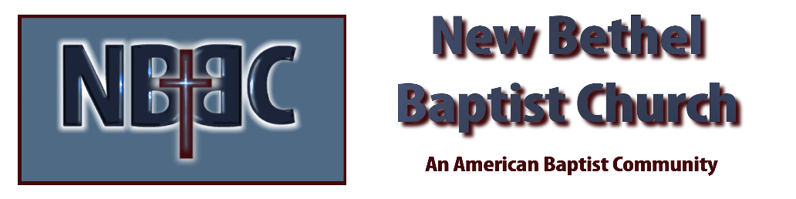

Sunday, April 12, 2026



