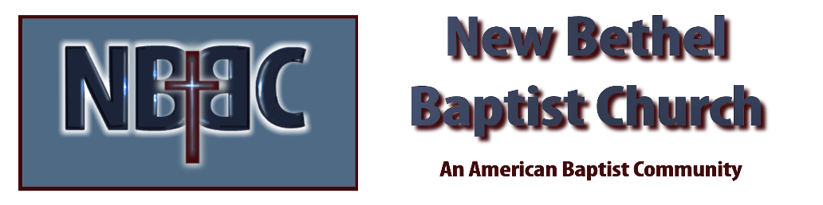

Sunday, April 4, 2026
Prelude Jaci Greig
Welcome & Announcements Phil Morgan
*Gathering Hymn Christ the Lord Is Risen Today #367
*Call to Worship
One: They were looking for a dead friend,
All: Mourning a loss,
One: Caught up in grief,
All: Worrying about stone-cold tombs.
One: They were prepared for death,
All: But not for life.
One: They were ready for sadness,
All: But not for joy.
One: Yet, Easter turned it around!
All: Turned the world upside down,
One: Set love on the throne,
All: Hope on the horizon,
One: Joy in each moment.
All: Easter still turns darkness around,
One: Makes our lives different,
All: Renews our hope,
One: Fills us with courage,
All: Gives us a song to sing
*Invocation and Lord’s Prayer (We use “sins”) Phil Morgan
Hymn He Lives #368

Scripture Reading John 20:1-18 Phil Morgan
One: Hear what God is saying to the people
Many: Thanks be to God

Worship Prayer Pastor Dianna Cline
Prayer Song Cares Chorus
Prayer (During the prayer you will have the opportunity to call out concerns and praises)
*Hymn Christ Arose #357

Scripture Reflection Matthew 28:1-10 Pastor Dianna Cline
“Come and Go”

*Hymn of Response Redeemed #356
(This is a time to come forward to join the church, rededicate your life, or be baptized)
Invitation to Respond Phil Morgan

Offertory Special Music by NBBC Choir
*Doxology
*Prayer Pastor Dianna Cline
Benediction
Postlude Jaci Greig

Lay Leader: Phil Morgan
Pianist: Jaci Greig
Today’s Ushers: Donna Carnes and Patrick Lynch

CONTACT INFORMATION
New Bethel Baptist Church Website: www.newbethelbapt.org
8936 Southeastern Avenue E-mail: newbethelbapt@att.net Indianapolis, IN 46239. Telephone: 317-862-4381 Wi-fi password: NBBC8624381

