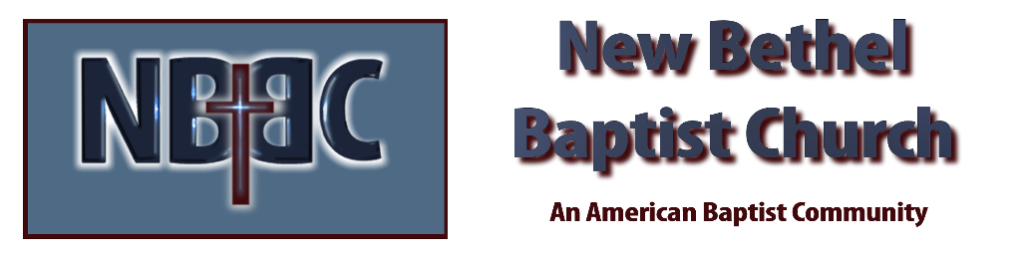
Sunday, May 24, 2026
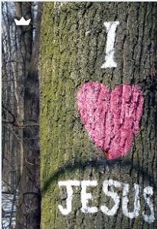
Prelude Jaci Greig
Welcome & Announcements Phil Morgan
Greeting of the Fellowship
*Gathering Hymn Spirit Song #384
*Call to Worship
One: Holy God, spare the earth,
All: But put a fire in our bones,
One: So our words are alive with hope,
All: Our hearts aflame with love,
One: Our deeds ablaze with compassion.
All: Holy God, spare us the winds of destruction,
One: But set loose your Spirit
All: That carries us along the paths of justice.
One: Holy God,
All: Be fire in our bones, wind at our back, a dove of peace. Be a Spirit of love, a song reborn, a life renewed.
*Invocation and Lord’s Prayer (We use “sins”) Phil Morgan
Hymn Shine, Jesus, Shine #431
Scripture Reading Acts 2:1-10 Phil Morgan
One: Hear what God is saying to the people
Many: Thanks be to God
Worship Prayer Pastor Dianna Cline
Prayer Song Cares Chorus
Prayer (During the prayer you will have the opportunity to call out concerns and praises)
*Hymn Come, Holy Spirit #382

Scripture Reflection Acts 2:11-21 Pastor Dianna Cline
“What’s in your heart”

*Hymn of Response Spirit of the Living God #389
(This is a time to come forward to join the church, rededicate your life, or be baptized)
Invitation to Respond Phil Morgan
Offertory
*Doxology
*Prayer Pastor Dianna Cline
Benediction God Be with You #232 Phil Morgan
Postlude Jaci Greig

Lay Leader: Phil Morgan
Pianist: Jaci Greig
Today’s Ushers: Liz Ballard and Greg West

Flowers arranged for May by Melody Lynch

CONTACT INFORMATION
New Bethel Baptist Church Website: www.newbethelbapt.org
8936 Southeastern Avenue E-mail: newbethelbapt@att.net Indianapolis, IN 46239 Telephone: 317-862-4381 Wi-fi password: NBBC8624381

