
Sunday, June 14, 2026
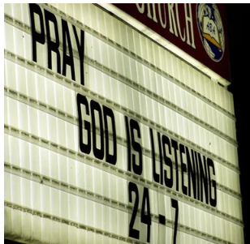
Prelude Jaci Greig
Welcome & Announcements Phil Morgan
Mission Moment Kevin Stone
Greeting of the Fellowship
*Gathering Hymn Praise to the Lord, the Almighty #210
*Call to Worship
Leader: Like the forlorn followers of Jesus at the empty tomb,
Congregation: We come seeking the living Christ.
Leader: Like the desolate disciples wandering lost on Holy Saturday,
Congregation: We come to find our way.
Leader: Like the persecuted apostles,
Congregation: We come to garnish courage.
Leader: Like a resurrection people.
All: We come with gratitude to praise our God.

*Invocation and Lord’s Prayer (We use “sins”) Phil Morgan
Hymn Praise Him! Praise Him! #12
Scripture Reading Psalm 100 Phil Morgan
One: Hear what God is saying to the people
Many: Thanks be to God
Worship Prayer Pastor Dianna Cline
Prayer Song Cares Chorus
Prayer (During the prayer you will have the opportunity to call out concerns and praises)
*Hymn Rescue the Perishing #441

Scripture Reflection Matthew 9:35-10:8 Pastor Dianna Cline
“AI and the workforce”

*Hymn of Response I Have Decided to Follow Jesus #602
(This is a time to come forward to join the church, rededicate your life, or be baptized)
Invitation to Respond Phil Morgan
Offertory Special music by Phil Morgan
*Doxology
*Prayer Pastor Dianna Cline
Benediction
Postlude Jaci Greig

Lay Leader: Phil Morgan
Pianist: Jaci Greig
Today’s Ushers: Jeannine Toon and Sherry Shoemaker

CONTACT INFORMATION
New Bethel Baptist Church Website: www.newbethelbapt.org
8936 Southeastern Avenue E-mail: newbethelbapt@att.net Indianapolis, IN 46239 Telephone: 317-862-4381 Wi-fi password: NBBC8624381

