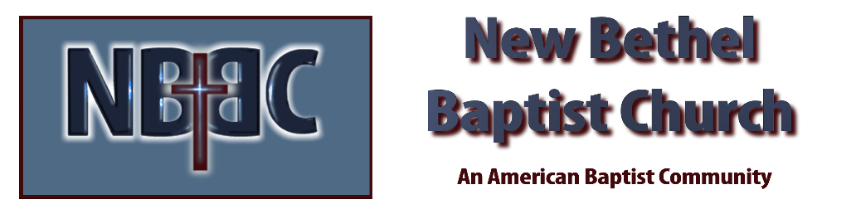
Sunday, June 21, 2026

Prelude Christina Romero
Welcome & Announcements Phil Morgan
Greeting of the Fellowship
*Gathering Hymn Praise to the Lord, the Almighty #210 (verses 1,3 & 4)
*Call to Worship
One: God invites us to be a people of generosity.
All: That’s our love offering to the world.
One: God invites us to remember our blessings.
All: That’s our love offering to the world.
One: God invites us to build a legacy of love.
All: That’s our love offering to the world.
One: God invites us to give cheerfully.
All: That’s our love offering to the world.

*Invocation and Lord’s Prayer (We use “sins”) Phil Morgan
Hymn God of Grace and God of Glory #435
Scripture Reading Psalm 69:7-18 Phil Morgan
One: Hear what God is saying to the people
Many: Thanks be to God
Worship Prayer Pastor Dianna Cline
Prayer Song Cares Chorus
Prayer (During the prayer you will have the opportunity to call out concerns and praises)
*Hymn Amazing Grace #343

Scripture Reflection Romans 6:1b-11 Pastor Dianna Cline
“Death and rebirth”

*Hymn of Response - Take My Life and Let it Be Consecrated - #597 (vs 1,5 & 6)
(This is a time to come forward to join the church, rededicate your life, or be baptized)
Invitation to Respond Phil Morgan
Offertory
*Doxology
*Prayer Pastor Dianna Cline
Benediction
Postlude Christina Romero

Lay Leader: Phil Morgan
Pianist: Christina Romero
Today’s Ushers: Patty Dammann and Pat Morgan

CONTACT INFORMATION
New Bethel Baptist Church Website: www.newbethelbapt.org
8936 Southeastern Avenue E-mail: newbethelbapt@att.net Indianapolis, IN 46239 Telephone: 317-862-4381 Wi-fi password: NBBC8624381

