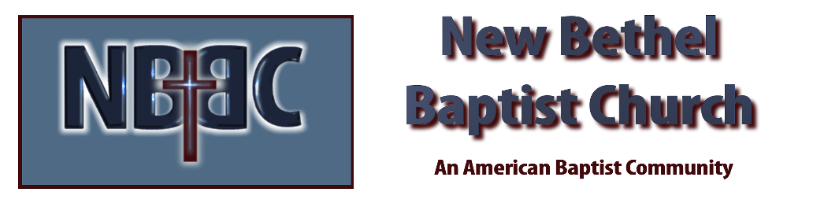
Sunday, July 26, 2026

Prelude Jaci Greig
Welcome & Announcements Phil Morgan
Greeting of the Fellowship
*Gathering Hymn How Great Thou Art #147 (vs. 1,3 & 4)
*Call to Worship
Leader: O great Healer, send your Spirit here to be with us today.
People: Reach into our hearts and lessen the pain and sorrow.
Leader: Heal and mend our brokenness and enable us to lift our spirits.
People: Dry the tears of sorrow and show us the hope of a new tomorrow.
Leader: Help us to find strength and courage here together in this place.
People: Together, Holy One, we sing praises and celebrate new life coming to us in God’s spirit.
*Invocation and Lord’s Prayer (We use “sins”) Phil Morgan
Hymn Thy Word #184
Scripture Reading Psalm 119:129-136 Phil Morgan
One: Hear what God is saying to the people
Many: Thanks be to God

Worship Prayer Pastor Dianna Cline
Prayer Song Cares Chorus
Prayer (During the prayer you will have the opportunity to call out concerns and praises)

*Hymn Standing on the Promises #410 (vs. 1,2,4, & 5)
Scripture Reflection Romans 8:26-39 Pastor Dianna Cline
“Do All Things Really Work Together?”

*Hymn of Response The Solid Rock #526
(This is a time to come forward to join the church, rededicate your life, or be baptized)
Invitation to Respond Phil Morgan
Offertory
*Doxology
*Prayer Pastor Dianna Cline
Benediction
Postlude Jaci Greig

Lay Leader: Phil Morgan
Pianist: Jaci Greig
Today’s Ushers: Liz Ballard and Greg West

CONTACT INFORMATION
New Bethel Baptist Church Website: www.newbethelbapt.org
8936 Southeastern Avenue E-mail: newbethelbapt@att.net Indianapolis, IN 46239 Telephone: 317-862-4381 Wi-fi password: NBBC8624381

