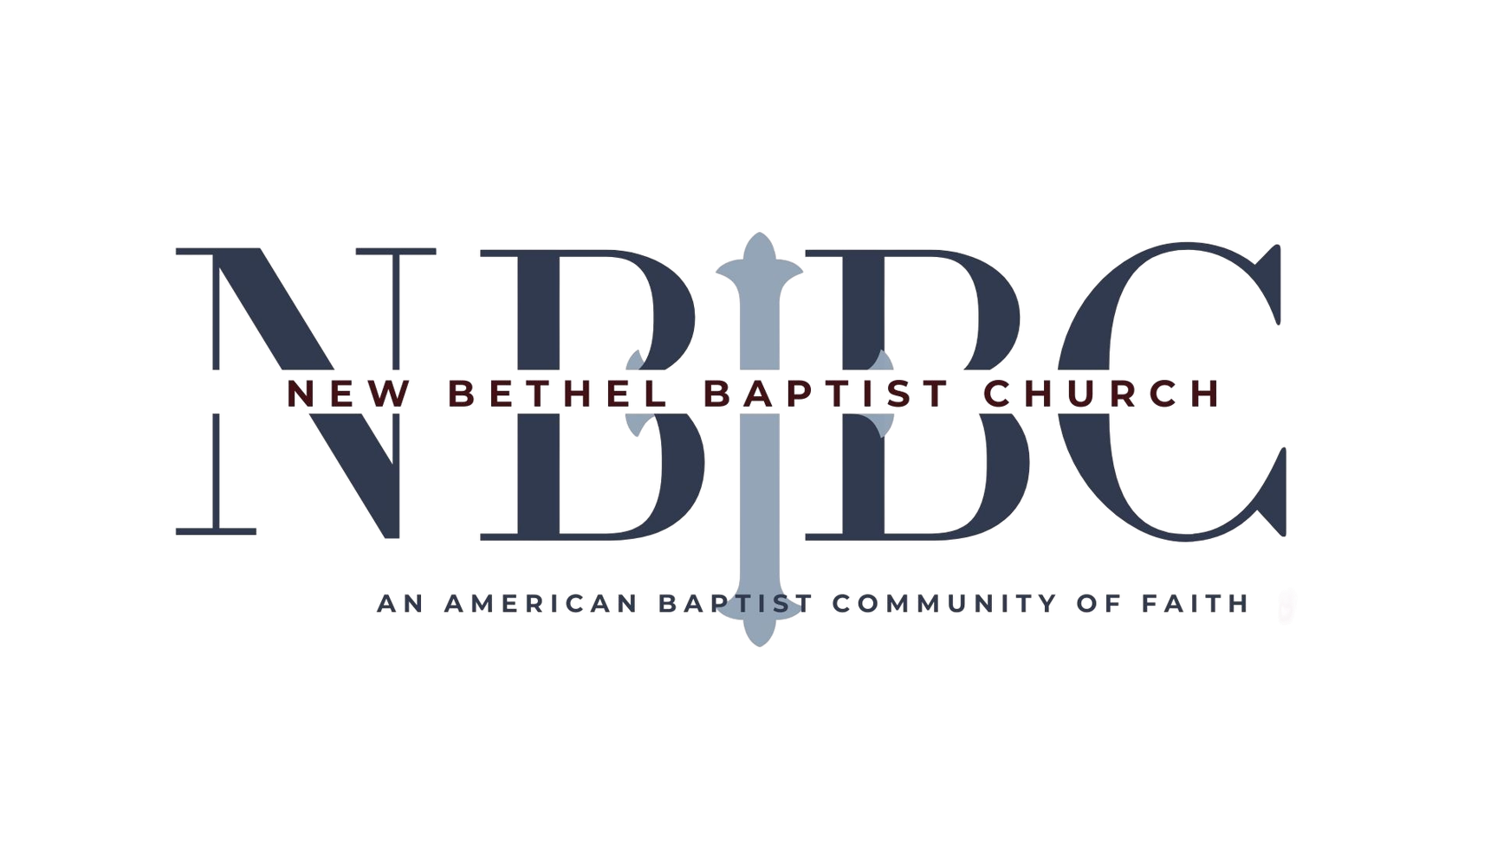
AUGUST 30, 2026
SUNDAY WORSHIP

PRELUDE
Jaci Greig
WELCOME & ANNOUNCEMENTS
Phil Morgan
GREETING OF FELLOWSHIP
*GATHERING HYMN
A Mighty Fortress Is Our God| #151
*CALL TO WORSHIP
Leader: Like a whisper that lures us to safety,
People: Strong as a shout that bids us to come,
Leader: Gentle as a prayer that eases our worry,
People: Like a clear bell that rings out our name,
Leader: Your Word comes to us, Loving God.
People: It calls us, comforts us and urges us to depart from
evil and do good, to seek peace and pursue it.
Leader: Talking God, open our hearts to hear you
People: And free our voices to praise you.
*INVOCATION AND LORD’S PRAYER
HYMN
My Faith Looks Up to Thee | #539
SCRIPTURE READING
Psalm 26:1-8
One: Hear what God is saying to the people.
Many: Thanks be to God!
WORSHIP PRAYER
Pastor Dianna Cline
Prayer Song | Cares Chorus
Prayer
(During the prayer, you will have the opportunity to call out concerns and praises)
*HYMN
There Is Power in the Blood | #329
SCRIPTURE REFLECTION
Pastor Dianna Cline
Romans 12:9-21 “Paul’s How-To Guide”
*HYMN OF RESPONSE
Take My Life and Let It Be Consecrated |#597 (1,5, & 6)
(This is a time to come forward to join the church, rededicate your life, or be baptized)
INVITATION TO RESPOND
OFFERTORY
*DOXOLOGY
*PRAYER
BENEDICTION / Pastor Dianna Cline
POSTLUDE / Jaci Greig

*Rise in body and spirit as you are able
Lay Leader | Phil Morgan
Pianist | Jaci Greig
Ushers | Sue and Jim

August Flowers | Ruth Ann Mills
TODAY’S WORSHIP LEADERS
WE ARE GLAD YOU ARE WORSHIPING WITH US TODAY.
Coffee and Jesus | Sundays at 9:00 a.m. - Worship | Sundays at 10:30 a.m.

